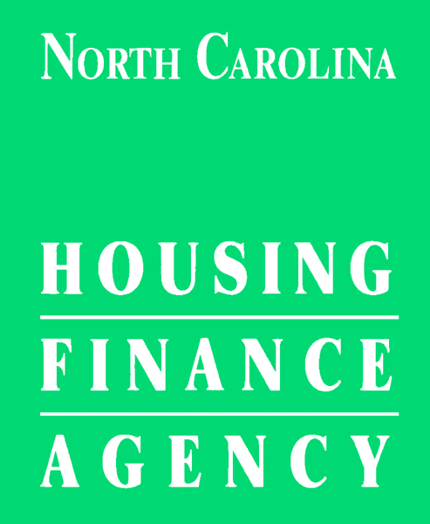

REQUEST FOR PRE-APPROVAL OF MANAGEMENT COMPANY OR
MANAGEMENT COMPANY CHANGE ON EXISTING PROPERTY
To be completed prior to changing management of tax credit property in NC.

Project Name: (“Project”)

Agency Project #: (if applicable)

Award Year: (if applicable)

Request Date: , 20

- Name of proposed Management Company:
- Authorized Official for the Management Company
(The person indicated as the Authorized Official is the authorized individual who can legally sign contracts or other legal documents on behalf of the management company.)
- Job Title
- EIN #
- Address
- Contact Phone Contact Email
- Primary Rental Compliance Reporting System Administrator
- Job Title
- Contact Phone Contact Email
- Effective Date of Change: , 20 (Actual or Proposed?)
Is the proposed management company on the Agency approved management list?
Requirements for management if new owner intends to change management companies:
The management agent must:
- have at least one similar tax credit project in their current portfolio,
- be requesting Key Program assistance timely and accurately (if applicable),
- be reporting in the Agency’s Rental Compliance Reporting System (RCRS) timely and accurately (if applicable),
- have at least one staff person in a supervisory capacity with regard to the project who has attended both basic and advanced Agency sponsored compliance training within the past 12 months, and
- have at least one staff person serving in a supervisory capacity with regard to the project who has been certified as a tax credit compliance specialist. Such certification must be from an organization approved by the Agency.
- have a valid North Carolina real estate license and be registered with the North Carolina Secretary of State. (Please provide a copy of the firm license.)
- adhere to rent increase approval requirements. Any management agent found to have implemented a rent increase on an existing property without the required Agency approval, may be disallowed from serving as management agent for an application.

None of the persons or entities serving as management agent may have in their portfolio a project with material or uncorrected noncompliance beyond the cure period unless there is a plan of action to address the issue(s).

Please provide the following required documentation if the proposed company is NOT an approved management company in good standing with NCHFA. We reserve the right to require any missing documentation from approved management companies, as necessary, in connection with this approval.
- Complete portfolio list, including property name, address, # of units, property type, and financing type
- Identify any uncorrected noncompliance for each property in the portfolio list
- Identify any defaults on any loan for each property in the portfolio list
- Proof of supervisor’s certification as a tax credit compliance specialist from an organization approved by NCHFA
- Proof of supervisor’s attendance at NCHFA training within the past 12 months
- Property Tenant Selection Policy and completed NCHFA checklist; which can be found on NCHFA website
- Copy of NC Broker’s license for the firm (not a personal license).

Property Owner/Partner signature:
(Current owner if no ownership change; Buyer if ownership is changing)
By: ____________________________
Name: ____________________________
Title: ____________________________
Date: , 20

Management Company Authorized Official signature:
By: ____________________________
Name: ____________________________
Title: ____________________________
Date: , 20

NCHFA signature:
By: ____________________________
Name: ____________________________
Title: ____________________________
Date: , 20

