Life Expectancy & Replacement Cost of Major Building Systems

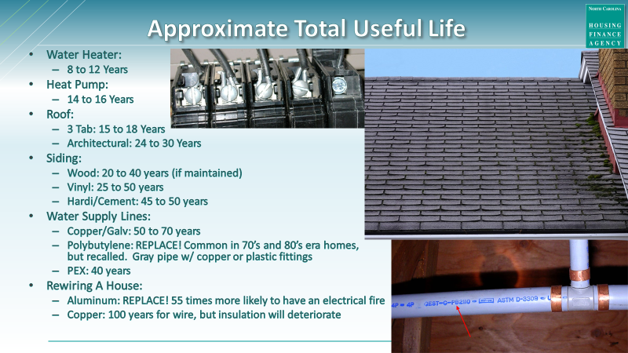

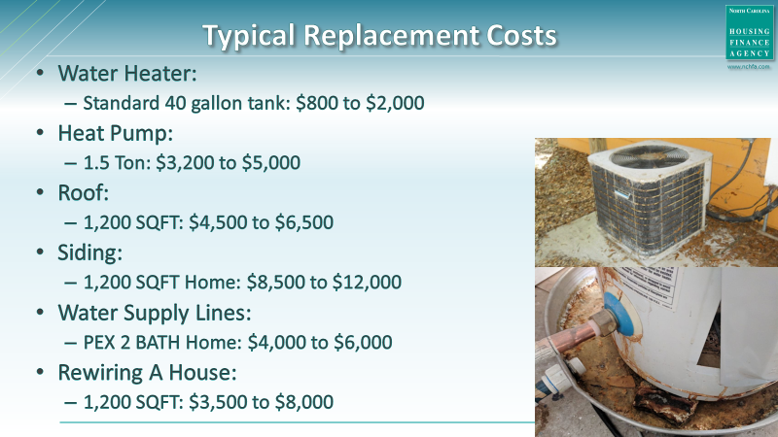

LIFE EXPECTANCY OF BUILDING SYSTEMS CHART
CATEGORY | SYSTEM | PRODUCT | USEFUL LIFE
PLUMBING | Drain Lines | PVC | Up to 100
 |  | Cast Iron | 75 to 100
 | Supply Lines | Copper/Brass | 50 to 75
 |  | CPVC | 25 to 30
 |  | PVC | Up to 75
 |  | Pex | Up to 40
 |  | Galvanized | 20 to 50
 |  | Lead | Replace
 |  | Polybutylene | Replace
 | Faucets | Kitchen | Up to 15
 |  | Bathroom | Up to 15
 | Toilets | Toilet | 100 +
 |  | Flush Valves | 5 to 10
 | Water Heater | Electric | 10 to 15
 |  | Gas | 8 to 12
 |  | Tankless | Up to 20
ROOF | Shingles | 3-tab | 10 to 20
 |  | Architectural | Up to 30
 |  | Cedar | 30 to 40
 | Metal | Metal | 40 to 70
ELECTRICAL | Wiring | Aluminum | Replace
 |  | Copper | 70 to 100
EXTERIOR | Siding | Wood | 20 to 40
 |  | Vinyl | 25 to 50
 |  | Hardi/Cement | 45 to 50
 | Decks | Wood Decking | Up to 15
 |  | Composite | 8 to 25
 |  | Structural Wood | 10 to 30
 | Doors | Wood | Up to 100
 |  | Fiberglass | Up to 100
 |  | Steel | Up to 100
 |  | Sliding Glass | Up to 20
 |  | Vinyl | Up to 20
 | Windows | Wood | Up to 30
 |  | Aluminum | 15 to 20
 |  | Vinyl | 20 to 40
CATEGORY | SYSTEM | PRODUCT | USEFUL LIFE
EXTERIOR – continue
 | Sealants | Paint | Up to 15
 |  | Caulk | Up to 15
HEATING & COOLING | HVAC | Electric Heat Pump | Up to 16
 |  | Gas Furnace | 15 to 20
KITCHEN | Appliances | Gas Range | 15 to 17
 |  | Electric Range | 13 to 15
 |  | Microwave | Up to 9
 |  | Freezer | 10 to 20
 |  | Refrigerator | 9 to 13
 |  | Dishwasher | Up to 9
 |  | Smoke Detectors | 8 to 10
FLOORING | Sheet | Vinyl | Up to 25
 |  | Carpet | 8 to 10
 |  | Linoleum | Up to 25
 |  | Concrete | 50 +
 | Plank | Wood | 100 +
 |  | Bamboo | 100 +
 |  | Tile | 75 to 100

